BALLYMAHON MUNICIPAL DISTRICT

Corporate Affairs,
Aras an Chontae,
LONGFOIRT.

26th February 2018.

To: Each Member of Ballymahon Municipal District.

Dear Member,

You are requested to attend Meeting of Ballymahon Municipal District to be held in
Balymahon Community Library at 12 noon on Friday, 2nd March 2018 to transact business, as set out on the Agenda hereunder.

Agenda.

1. To consider and approve Schedule of Ballymahon Municipal District Works - Report enclosed.

Yours sincerely,

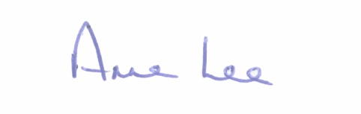

_______________
Anne Lee,
Meetings Administrator.

